Visoka škola strukovnih studija za informacione i komunikacione tehnologije u Beogradu

Visoka ICT škola

Web programiranje 1 – Dokumentacija za sajt

Ime I prezime studenta: Damnjan Ašković

Broj indeksa: 174/17

Decembar 2018, Beograd

Sadržaj:

1. Uvod
   1. Korišćeni programski i markup jezici
   2. Opis funkcionalnosti
   3. Template
   4. Korišćeni CSS
2. Organizacija
   1. Organizaciona šema
   2. Mapa sajta
   3. Stranice
3. Kodovi

# Uvod

U prilogu se nalazi sajt za predmet Web Programiranje 1, napravljen na temu o Hari Poteru. Sajt je Responsive .

1.1. Korišćeni programski i markup jezici

HTML, CSS, Javascript

Koriscene biblioteke

JQuery (JavaScript)

JQuery plug-in

Flexslider (<http://flexslider.woothemes.com/?fbclid=IwAR0Ds6ggD2FBssaq4-Zu11prgVTJbfqnWg1mR9uSP41icKH3_FxwG5KfppY>)

Okruženje

Sublime Text 3

1.2 Opis funkcionalnosti

**Stranica index.html**

Dinamičko ispisivanje

Glasanje (JavaScript) – ispisani su svi elementi dinamički

Ostatak funkcionalnosti

Nakon čekiranja odredjenog broja čekboks elemenata korisniku se ispisuje poruka o najviše dva čekirana elementa. Ukoliko korisnik nije dobro čekirao, ispisaće se poruka o greškama. Kada se ispravno čekira, ispisuju se čekirani elementi I dugme za glasanje se sakriva.

**Stranica hogwarts.html**

Preko JQuery-a uradjena zebra na tabeli. Svaki drugi red je obojen drugom bojom.

**Stranica gallery.html**

Napravljen slajder slika pomoću plug-in-a preko Jquery-a, korišćen je flexslider da nakon pet sekundi menja slike, I kada dodje do poslednje slike, da vrati na prvu sliku. U sebi sadži strelice za prethodnu I sledeću I bullete koji stoje ispod slika I ukazuju na trenutnu sliku.

**Stranica contact.html**

Dinamičko ispisivanje

Padajuca lista (JavaScript) – ispisana lista dinamički

Ostatak funkcionalnosti

Klikom na dugmad SUBMIT YOUR MESSAGE, LOGIN I REGISTER izvršava se validacija formi za kontakt, prijavljivanje I registrovanje. Ukoliko se dogode neke greške tj ukoliko dodje do pogrešnog popunjavanja nekog polja, u neuredjenoj listi ispod dugmadi će se crvenom bojom I podvučenom tačkastom linijom ispisati poruka o greškama I način na koji forma treba biti popunjena. U slučaju da nema grešaka vrednosti polja će se ispisati drugom bojom takodje u neuredjenoj listi I forma će se resetovati.

**Stranica about.html**

Pri pristupu stranici about nakon klika na dugme ABOUT ME, stranica se spusta na section I nakon tri sekunde pomoću funkcije FADEIN “ulazi” slika autora sajta.

1.3.Template

Nisam koristio nijedan gotov template jer je ovo moj sajt koji sam napravio za predmet Praktikum iz Web Dizajna.

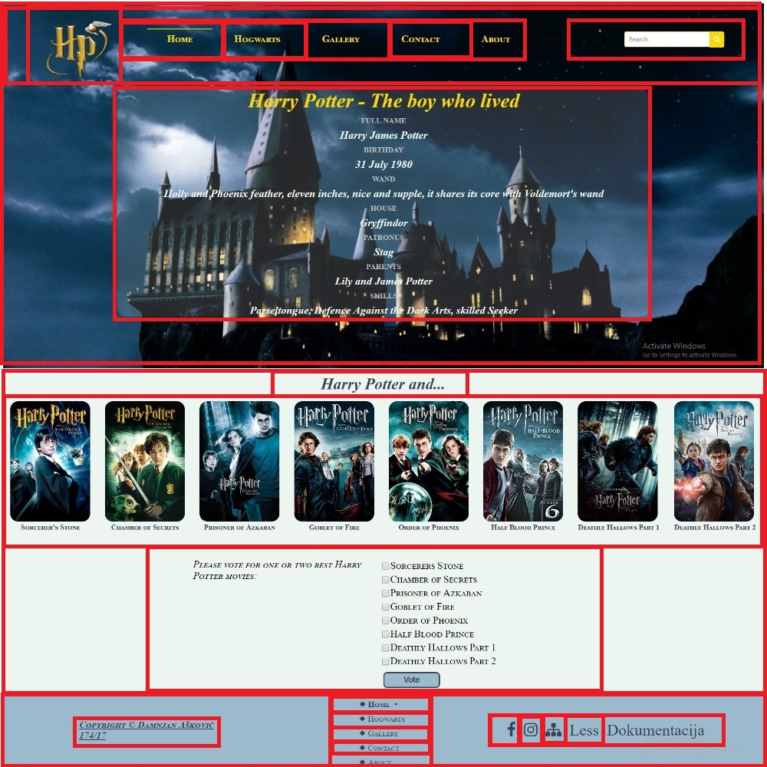

<!DOCTYPE html>

<html>

<head>

<title>Pottermania</title>

<meta charset="UTF-8"/>

<meta name="author" content="Askovic Damnjan 174.17"/>

<meta name="keywords" content="Harry Potter, Hogwarts, Magic"/>

<meta name="language" content="English"/>

<meta name="viewport" content="width=device-width, initial-scale=1.0" />

<link rel="stylesheet" type="text/css" href="css/style.css" />

<link rel="stylesheet" type="text/css" href="css/main.css" />

<link rel="icon" href="images/favicon.ico" />

<link rel="stylesheet" href="https://cdnjs.cloudflare.com/ajax/libs/font-awesome/4.7.0/css/font-awesome.min.css" />

<link href="http://www.fontsaddict.com/font/harry-potter.html" rel="stylesheet" />

</head>

<body>

<div id="omot">

<header>

<div id="pozadina">

<div id="glavni">

<div id="logo">

<a href="index.html"><img src="images/logo.png" alt="Logo"></a>

</div>

<div id="meni" class="topnav">

<ul>

<li class="aktivanLink"><a href="index.html">Home</a></li>

<li class="flexmeni"><a href="index.html">Home</a></li>

<li><a href="hogwarts.html">Hogwarts</a></li>

<li><a href="gallery.html">Gallery</a></li>

<li><a href="contact.html">Contact</a></li>

<li><a href="about.html">About</a></li>

<li><a href="javascript:void(0);" class="icon" onclick="myFunction()">

<span class="fa fa-bars"></span>

</a>

</li>

</ul>

</div>

<div id="pretraga">

<form action="#" method="GET">

<input type="text" name="tbPretraga" id="tbPretraga" placeholder="Search.." />

<button type="submit" id="tbDugme"> <i class="fa fa-search"></i> </button>

</form>

</div>

<div class="cleaner"></div>

<div id="more">

<h1 id="naslov">Harry Potter - The boy who lived</h1>

<dl id="informacije">

<dt class="info">FULL NAME</dt>

<dd class="podaci"><p>Harry James Potter</p></dd>

<dt class="info">BIRTHDAY</dt>

<dd class="podaci"><p>31 July 1980</p></dd>

<dt class="info">WAND</dt>

<dd class="podaci"><p>Holly and Phoenix feather, eleven inches, nice and supple, it shares its core with Voldemort's wand</p></dd>

<dt class="info">HOUSE</dt>

<dd class="podaci"><p>Gryffindor</p></dd>

<dt class="info">PATRONUS</dt>

<dd class="podaci"><p>Stag</p></dd>

<dt class="info">PARENTS</dt>

<dd class="podaci"><p>Lily and James Potter</p></dd>

<dt class="info">SKILLS</dt>

<dd class="podaci"><p>Parseltongue, Defence Against the Dark Arts, skilled Seeker</p></dd>

</dl>

</div>

</div>

</div>

</header>

<main>

<h2 id="delovi"> Harry Potter and... </h2>

<div id="parts">

<figure class="slika">

<img src="images/prvi.jpg" alt="Part 1"/>

<figcaption class="part">Sorcerer's Stone</figcaption>

</figure>

<figure class="slika">

<img src="images/drugi.jpg" alt="Part 2"/>

<figcaption class="part">Chamber of Secrets</figcaption>

</figure>

<figure class="slika">

<img src="images/treci.jpg" alt="Part 3" />

<figcaption class="part">Prisoner of Azkaban</figcaption>

</figure>

<figure class="slika">

<img src="images/cetvrti.jpg" alt="Part 4" />

<figcaption class="part">Goblet of Fire</figcaption>

</figure>

<figure class="slika">

<img src="images/peti.jpg" alt="Part 5"/>

<figcaption class="part">Order of Phoenix</figcaption>

</figure>

<figure class="slika">

<img src="images/sesti.jpg" alt="Part 6"/>

<figcaption class="part">Half Blood Prince</figcaption>

</figure>

<figure class="slika">

<img src="images/sedmi.jpg" alt="Part 7" />

<figcaption class="part">Deathly Hallows Part 1</figcaption>

</figure>

<figure class="slika">

<img src="images/sedmi2.jpg" alt="Part 7" />

<figcaption class="part">Deathly Hallows Part 2</figcaption>

</figure>

</div>

<div class="questionMovie">

<div class="bestMovies">

<div id = "vote-result" class="movieVote">

<span><i>Please vote for one or two best Harry Potter movies: </i></span><br/><br/>

<div id="vote"></div>

</div>

<div id="movies-form" class="movieVote">

<div id="moviesList"></div>

<button type="button" id="btnVote" class="dugme">Vote</button>

</div>

<div class="cleaner"></div>

</div>

</div>

</main>

<footer>

<div id="autor">

<h3 id="naslovFuter"><a href="about.html">Copyright &copy Damnjan Ašković 174/17</a></h3>

</div>

<div id="meniFuter">

<ul>

<li class="aktivanLink"><a href="index.html"> &#x25C6 Home &#x25C2 </a></li>

<li><a href="hogwarts.html"> &#x25C6 Hogwarts </a></li>

<li><a href="gallery.html"> &#x25C6 Gallery </a></li>

<li><a href="contact.html"> &#x25C6 Contact </a></li>

<li><a href="about.html"> &#x25C6 About </a></li>

</ul>

</div>

<div id="social">

<ul>

<li><a href="https://www.facebook.com/harrypottermovie/" target="_blank"> <span class="fa fa-facebook"></span></a></li>

<li><a href="https://www.instagram.com/harrypotterfilm/" target="_blank"> <span class="fa fa-instagram"></span></a></li>

<li><a href="sitemap.xml" target="_blank"> <i class="fa fa-sitemap"></i></a></li>

<li><a href="less.txt" target="_blank">Less</a></li>

<li><a href="dokumentacija.pdf" target="_blank">Dokumentacija</i></a></li>

</ul>

</div>

</footer>

</div>

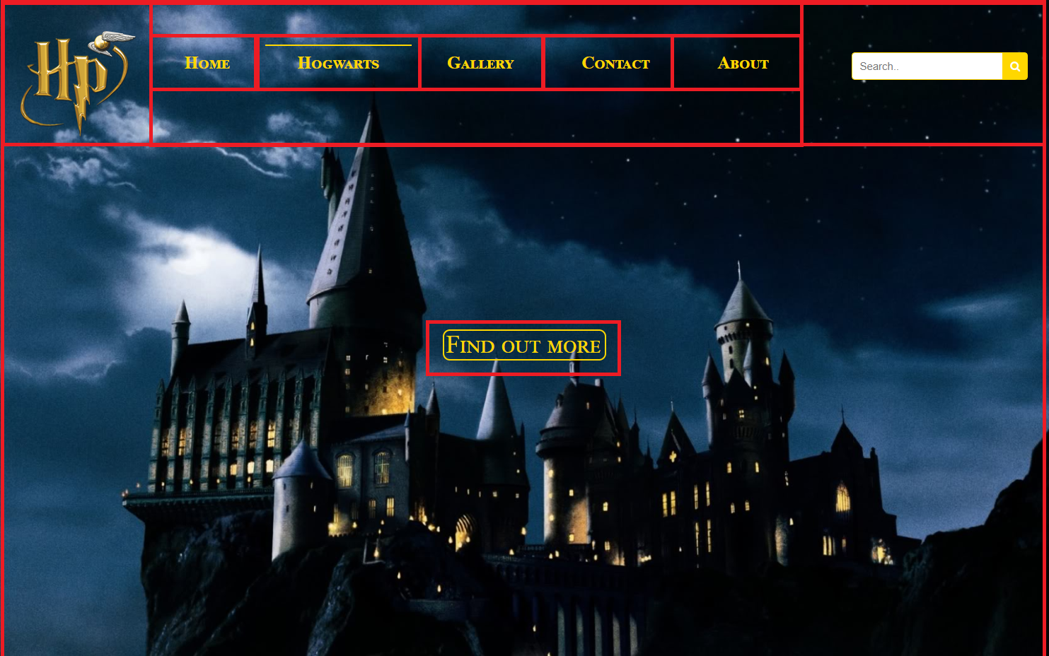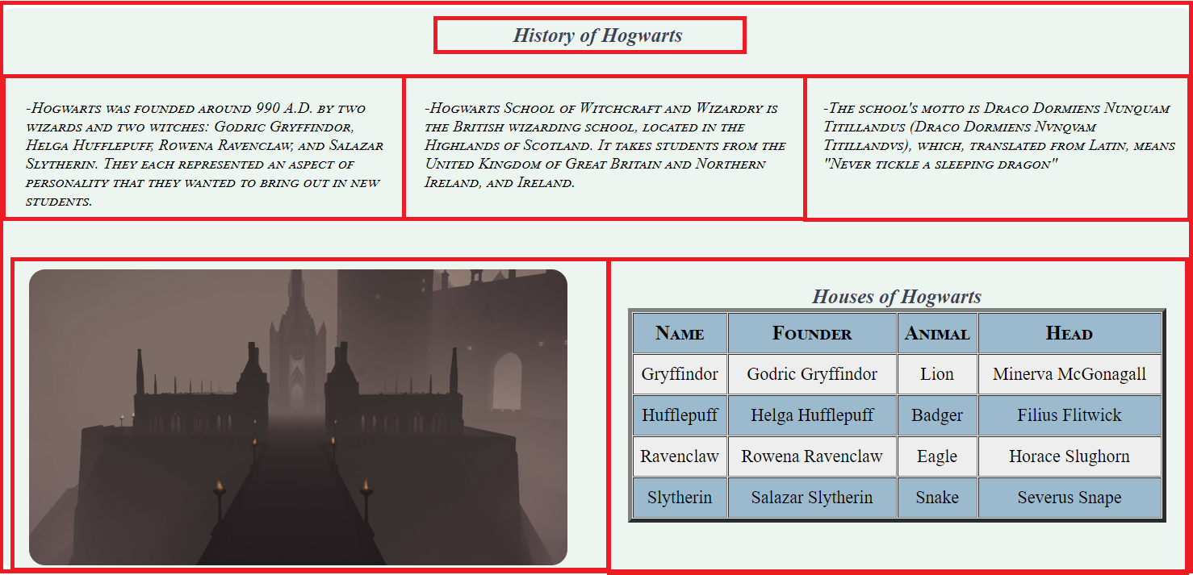

<!DOCTYPE html>

<html>

<head>

<title>Pottermania</title>

<meta charset="UTF-8"/>

<meta name="author" content="Askovic Damnjan 174.17"/>

<meta name="keywords" content="Harry Potter, Hogwarts, Magic"/>

<meta name="language" content="English"/>

<meta name="viewport" content="width=device-width, initial-scale=1.0">

<link rel="stylesheet" type="text/css" href="css/hogwarts.css">

<link rel="stylesheet" type="text/css" href="css/main.css" />

<link rel="icon" href="images/favicon.ico">

<link rel="stylesheet" href="https://cdnjs.cloudflare.com/ajax/libs/font-awesome/4.7.0/css/font-awesome.min.css">

<link href="http://www.fontsaddict.com/font/harry-potter.html" rel="stylesheet">

</head>

<body>

<div id="omot">

<header>

<div id="pozadina">

<div id="glavni">

<div id="logo">

<a href="index.html"><img src="images/logo.png" alt="Logo"></a>

</div>

<div id="meni" class="topnav">

<ul>

<li><a href="index.html">Home</a></li>

<li class="flexmeni"><a href="index.html">Home</a></li>

<li class="aktivanLink"><a href="hogwarts.html">Hogwarts</a></li>

<li><a href="gallery.html">Gallery</a></li>

<li><a href="contact.html">Contact</a></li>

<li><a href="about.html">About</a></li>

<li><a href="javascript:void(0);" class="icon" onclick="myFunction()">

<span class="fa fa-bars"></span>

</a>

</li>

</ul>

</div>

<div id="pretraga">

<form action="#" method="GET">

<input type="text" name="tbPretraga" id="tbPretraga" placeholder="Search.." />

<button type="submit" id="tbDugme"> <i class="fa fa-search"></i> </button>

</form>

</div>

<div class="cleaner"></div>

<div id="prebaci">

<a href="#fact" id="dugmes">Find out more</a>

</div>

</div>

</div>

</header>

<main>

<section id="fact">

<h3>History of Hogwarts</h3>

<div class="row">

<div class="col">

<blockquote>

<p>-Hogwarts was founded around 990 A.D. by two wizards and two witches: Godric Gryffindor, Helga Hufflepuff, Rowena Ravenclaw, and Salazar Slytherin. They each represented an aspect of personality that they wanted to bring out in new students.</p>

</blockquote>

</div>

<div class="col">

<blockquote>

<p>-Hogwarts School of Witchcraft and Wizardry is the British wizarding school, located in the Highlands of Scotland. It takes students from the United Kingdom of Great Britain and Northern Ireland, and Ireland.</p>

</blockquote>

</div>

<div class="col">

<blockquote>

<p>-The school's motto is Draco Dormiens Nunquam Titillandus (Draco Dormiens Nvnqvam Titillandvs), which, translated from Latin, means "Never tickle a sleeping dragon"</p>

</blockquote>

</div>

<div class="cleaner">

</div>

</div>

<div class="row">

<div class="col-1-of-2 slika">

<img src="images/ulaz.jpg" alt="Entrance">

</div>

<div class="col-1-of-2">

<h3>Houses of Hogwarts</h3>

<table border="5px" width="100%" cellpadding="1px" cellspacing="1px" id="kuca">

<tr>

<th>Name</th>

<th>Founder</th>

<th>Animal</th>

<th>Head</th>

</tr>

<tr>

<td>Gryffindor</td>

<td>Godric Gryffindor</td>

<td>Lion</td>

<td>Minerva McGonagall</td>

</tr>

<tr>

<td>Hufflepuff</td>

<td>Helga Hufflepuff</td>

<td>Badger</td>

<td>Filius Flitwick</td>

</tr>

<tr>

<td>Ravenclaw</td>

<td>Rowena Ravenclaw</td>

<td>Eagle</td>

<td>Horace Slughorn</td>

</tr>

<tr>

<td>Slytherin</td>

<td>Salazar Slytherin</td>

<td>Snake</td>

<td>Severus Snape</td>

</tr>

</table>

</div>

<div class="cleaner">

</div>

</div>

</section>

</main>

<footer>

<div id="autor">

<h3 id="naslovFuter"><a href="about.html">Copyright &copy Damnjan Ašković 174/17</a></h3>

</div>

<div id="meniFuter">

<ul>

<li><a href="index.html">&#x25C6 Home</a></li>

<li class="aktivanLink"><a href="hogwarts.html">&#x25C6 Hogwarts &#x25C2</a></li>

<li><a href="gallery.html">&#x25C6 Gallery</a></li>

<li><a href="contact.html">&#x25C6 Contact</a></li>

<li><a href="about.html">&#x25C6 About</a></li>

</ul>

</div>

<div id="social">

<ul>

<li><a href="https://www.facebook.com/harrypottermovie/" target="_blank"> <i class="fa fa-facebook"></i></a></li>

<li><a href="https://www.instagram.com/harrypotterfilm/" target="_blank"> <i class="fa fa-instagram"></i></a></li>

<li><a href="sitemap.xml" target="_blank"> <i class="fa fa-sitemap"></i></a></li>

<li><a href="less.txt" target="_blank">Less</a></li>

<li><a href="dokumentacija.docx" target="_blank">Dokumentacija</i></a></li>

</ul>

</div>

</footer>

</div>

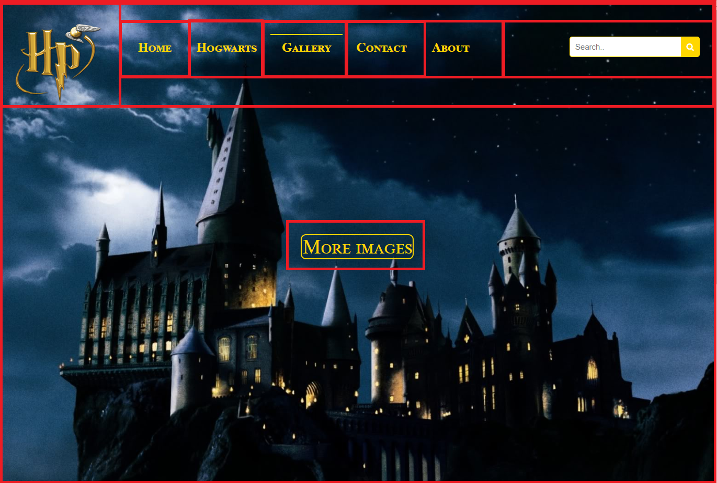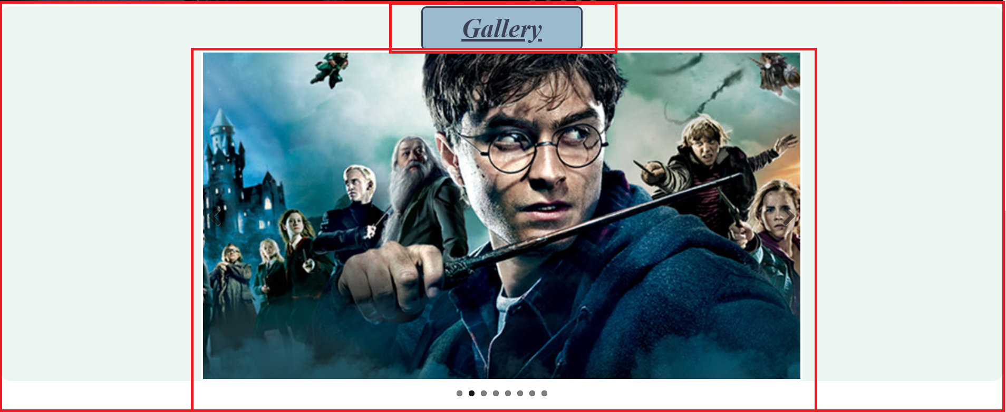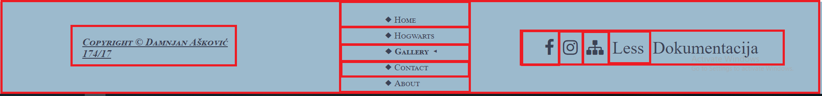

<!DOCTYPE html>

<html>

<head>

<title>Pottermania</title>

<meta charset="UTF-8"/>

<meta name="author" content="Askovic Damnjan 174.17"/>

<meta name="keywords" content="Harry Potter, Hogwarts, Magic"/>

<meta name="language" content="English"/>

<meta name="viewport" content="width=device-width, initial-scale=1.0">

<link rel="stylesheet" type="text/css" href="css/gallery.css">

<link rel="stylesheet" type="text/css" href="css/main.css" />

<link rel="stylesheet" type="text/css" href="plugin/FlexSlider/flexslider.css" />

<link rel="icon" href="images/favicon.ico">

<link rel="stylesheet" href="https://cdnjs.cloudflare.com/ajax/libs/font-awesome/4.7.0/css/font-awesome.min.css">

<link href="http://www.fontsaddict.com/font/harry-potter.html" rel="stylesheet">

</head>

<body>

<div id="omot">

<header>

<div id="pozadina">

<div id="glavni">

<div id="logo">

<a href="index.html"><img src="images/logo.png" alt="Logo"></a>

</div>

<div id="meni" class="topnav">

<ul>

<li><a href="index.html">Home</a></li>

<li class="flexmeni"><a href="index.html">Home</a></li>

<li><a href="hogwarts.html">Hogwarts</a></li>

<li class="aktivanLink"><a href="gallery.html">Gallery</a></li>

<li><a href="contact.html">Contact</a></li>

<li><a href="about.html">About</a></li>

<li><a href="javascript:void(0);" class="icon" onclick="myFunction()">

<span class="fa fa-bars"></span>

</a>

</li>

</ul>

</div>

<div id="pretraga">

<form action="#" method="GET">

<input type="text" name="tbPretraga" id="tbPretraga" placeholder="Search.." />

<button type="submit" id="tbDugme"> <i class="fa fa-search"></i> </button>

</form>

</div>

<div class="cleaner"></div>

<div id="prebaci">

<a href="#naslov" id="dugmes">More images</a>

</div>

</div>

</div>

</header>

<main>

<div id="naslov">

<h1>Gallery</h1>

</div>

<div id="slider" class="pictures-slide">

<div class="flexslider">

<ul class="slides">

<li>

<img src="images/hari.jpg" alt="Harry Potter">

</li>

<li>

<img src="images/battle.jpg" alt="Harry Potter">

</li>

<li>

<img src="images/patronus.jpg" alt="Patronus">

</li>

<li>

<img src="images/hrjh.jpg" alt="Harry Ginny Hermione Ron">

</li>

<li>

<img src="images/hat.jpg" alt="Hat">

</li>

<li>

<img src="images/lupin.jpg" alt="Professor Lupin">

</li>

<li>

<img src="images/snape.jpg" alt="Professor Snape">

</li>

<li>

<img src="images/rhh.jpg" alt="Ron Hermione Harry">

</li>

</ul>

</div>

</div>

</main>

<footer>

<div id="autor">

<h3 id="naslovFuter"><a href="about.html">Copyright &copy Damnjan Ašković 174/17</a></h3>

</div>

<div id="meniFuter">

<ul>

<li><a href="index.html">&#x25C6 Home</a></li>

<li><a href="hogwarts.html">&#x25C6 Hogwarts</a></li>

<li class="aktivanLink"><a href="gallery.html">&#x25C6 Gallery &#x25C2</a></li>

<li><a href="contact.html">&#x25C6 Contact</a></li>

<li><a href="about.html">&#x25C6 About</a></li>

</ul>

</div>

<div id="social">

<ul>

<li><a href="https://www.facebook.com/harrypottermovie/" target="_blank"> <i class="fa fa-facebook"></i></a></li>

<li><a href="https://www.instagram.com/harrypotterfilm/" target="_blank"> <i class="fa fa-instagram"></i></a></li>

<li><a href="sitemap.xml" target="_blank"> <i class="fa fa-sitemap"></i></a></li>

<li><a href="less.txt" target="_blank">Less</a></li>

<li><a href="dokumentacija.docx" target="_blank">Dokumentacija</i></a></li>

</ul>

</div>

</footer>

</div>

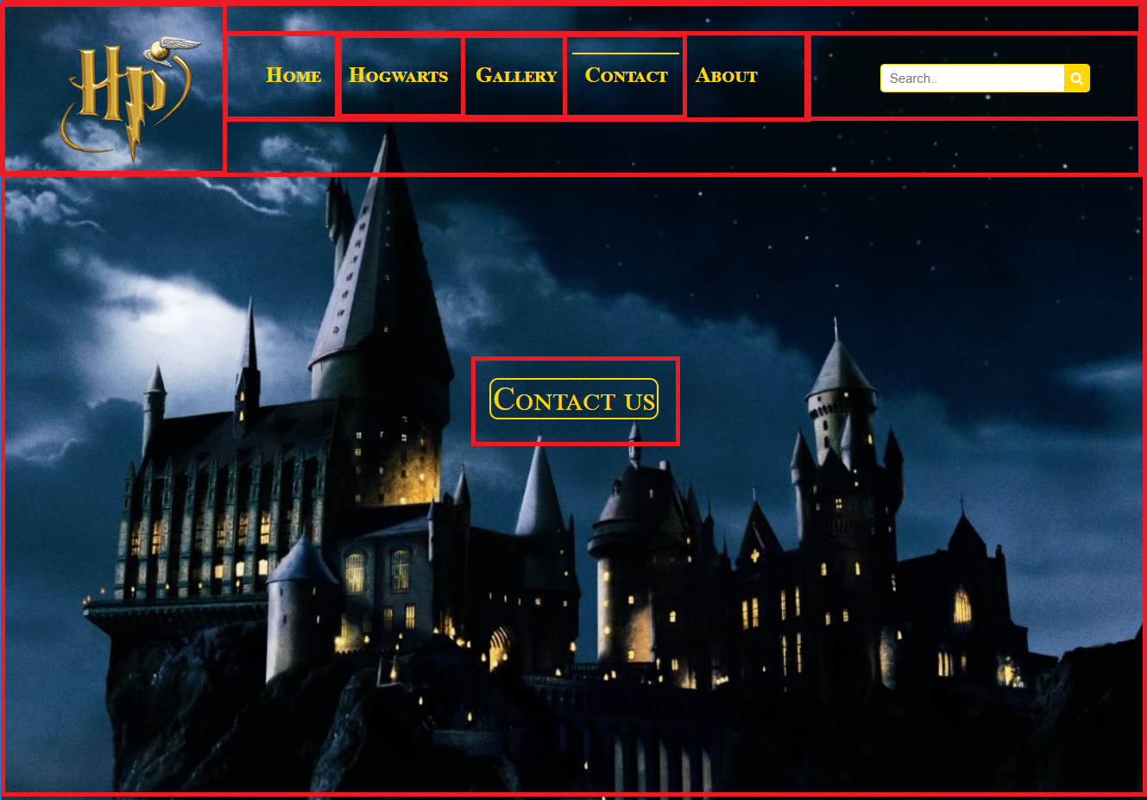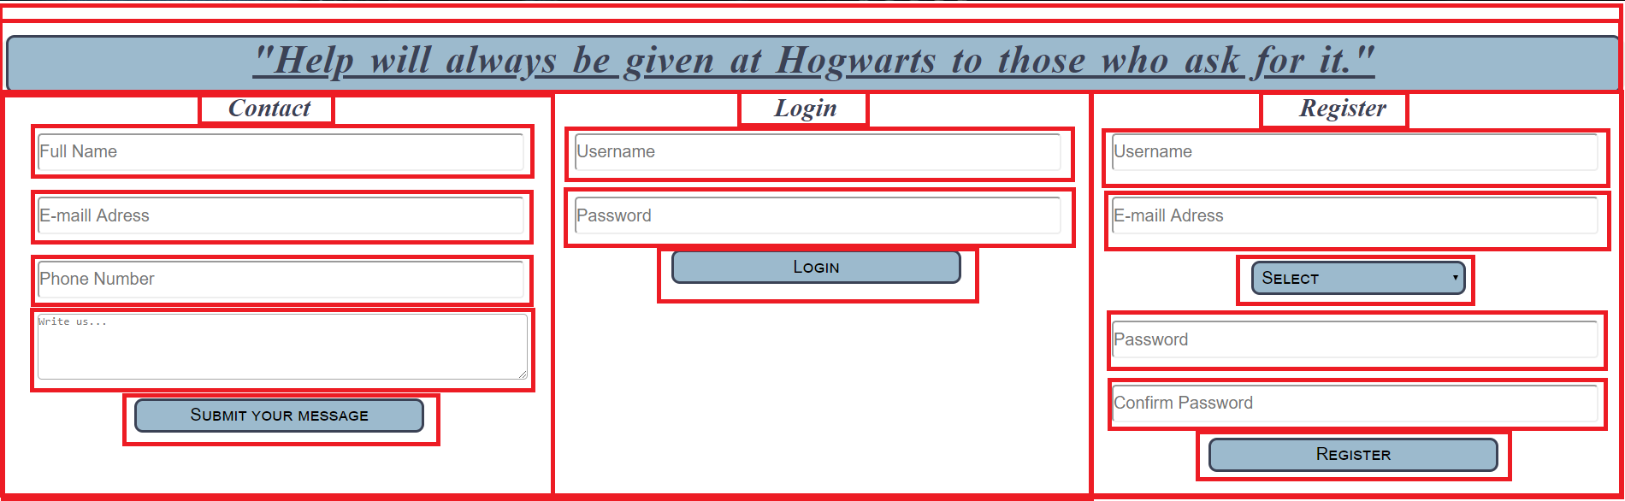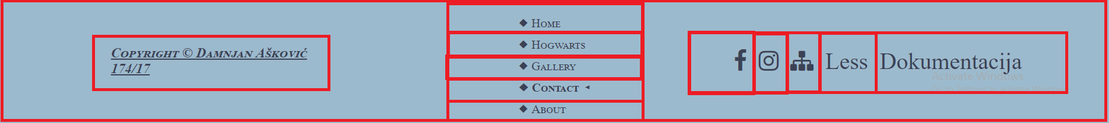

<!DOCTYPE html>

<html>

<head>

<title>Pottermania</title>

<meta charset="UTF-8"/>

<meta name="author" content="Askovic Damnjan 174.17"/>

<meta name="keywords" content="Harry Potter, Hogwarts, Magic"/>

<meta name="language" content="English"/>

<meta name="viewport" content="width=device-width, initial-scale=1.0">

<link rel="stylesheet" type="text/css" href="css/contact.css">

<link rel="stylesheet" type="text/css" href="css/main.css" />

<link rel="icon" href="images/favicon.ico">

<link rel="stylesheet" href="https://cdnjs.cloudflare.com/ajax/libs/font-awesome/4.7.0/css/font-awesome.min.css">

<link href="http://www.fontsaddict.com/font/harry-potter.html" rel="stylesheet">

</head>

<body>

<div id="omot">

<header>

<div id="pozadina">

<div id="glavni">

<div id="logo">

<a href="index.html"><img src="images/logo.png" alt="Logo"></a>

</div>

<div id="meni" class="topnav">

<ul>

<li><a href="index.html">Home</a></li>

<li class="flexmeni"><a href="index.html">Home</a></li>

<li><a href="hogwarts.html">Hogwarts</a></li>

<li><a href="gallery.html">Gallery</a></li>

<li class="aktivanLink"><a href="contact.html">Contact</a></li>

<li><a href="about.html">About</a></li>

<li><a href="javascript:void(0);" class="icon" onclick="myFunction()">

<span class="fa fa-bars"></span>

</a>

</li>

</ul>

</div>

<div id="pretraga">

<form action="#" method="GET">

<input type="text" name="tbPretraga" id="tbPretraga" placeholder="Search.." />

<button type="submit" id="tbDugme"> <i class="fa fa-search"></i> </button>

</form>

</div>

<div class="cleaner"></div>

<div id="prebaci">

<a href="#naslov" id="dugmes">Contact us</a>

</div>

</div>

</div>

</header>

<main>

<div id="naslov">

<h1>"Help will always be given at Hogwarts to those who ask for it."</h1>

</div>

<div class="form-div">

<h2>Contact</h2>

<form onsubmit="return false" id="contactForm">

<input type="text" placeholder="Full Name" class="polja" id="fullName"></br></br>

<input type="text" placeholder="E-maill Adress" class="polja" id="emailContact"></br></br>

<input type="text" placeholder="Phone Number" class="polja" id="phoneContact"></br></br>

<textarea cols="47" rows="5" class="write-text" placeholder="Write us..." id="textContact"></textarea></br></br>

<input type="submit" name="posalji" value="Submit your message" id="submitContact" class="dugme">

</form>

<div id="validInfo" class="show-validated">

</div>

</div>

<div class="form-div">

<h2>Login</h2>

<form onsubmit="return false" id="loginForm">

<input type="text" placeholder="Username" class="polja" id="usernameLogin"></br></br>

<input type="password" placeholder="Password" class="polja" id="passwordLogin"></br></br>

<button type="submit" class="dugme" id="btnLogin">Login</button>

</form>

<div id="validLogin" class="show-validated">

</div>

</div>

<div class="form-div">

<h2>Register</h2>

<form onsubmit="return false" id="registerForm">

<input type="text" placeholder="Username" class="polja" id="usernameRegister"></br></br>

<input type="text" placeholder="E-maill Adress" class="polja" id="emailRegister"></br></br>

<input type="password" placeholder="Password" class="polja" id="passwordRegister"></br></br>

<input type="password" placeholder="Confirm Password" class="polja" id="confPasswordRegister"></br></br>

<button type="submit" class="dugme" id="btnRegister">Register</button>

</form>

<div id="validReg" class="show-validated">

</div>

</div>

</main>

<footer>

<div id="autor">

<h3 id="naslovFuter"><a href="about.html">Copyright &copy Damnjan Ašković 174/17</a></h3>

</div>

<div id="meniFuter">

<ul>

<li><a href="index.html">&#x25C6 Home</a></li>

<li><a href="hogwarts.html">&#x25C6 Hogwarts</a></li>

<li><a href="gallery.html">&#x25C6 Gallery</a></li>

<li class="aktivanLink"><a href="contact.html">&#x25C6 Contact &#x25C2</a></li>

<li><a href="about.html">&#x25C6 About</a></li>

</ul>

</div>

<div id="social">

<ul>

<li><a href="https://www.facebook.com/harrypottermovie/" target="_blank"> <i class="fa fa-facebook"></i></a></li>

<li><a href="https://www.instagram.com/harrypotterfilm/" target="_blank"> <i class="fa fa-instagram"></i></a></li>

<li><a href="sitemap.xml" target="_blank"> <i class="fa fa-sitemap"></i></a></li>

<li><a href="less.txt" target="_blank">Less</a></li>

<li><a href="dokumentacija.docx" target="_blank">Dokumentacija</i></a></li>

</ul>

</div>

</footer>

</div>

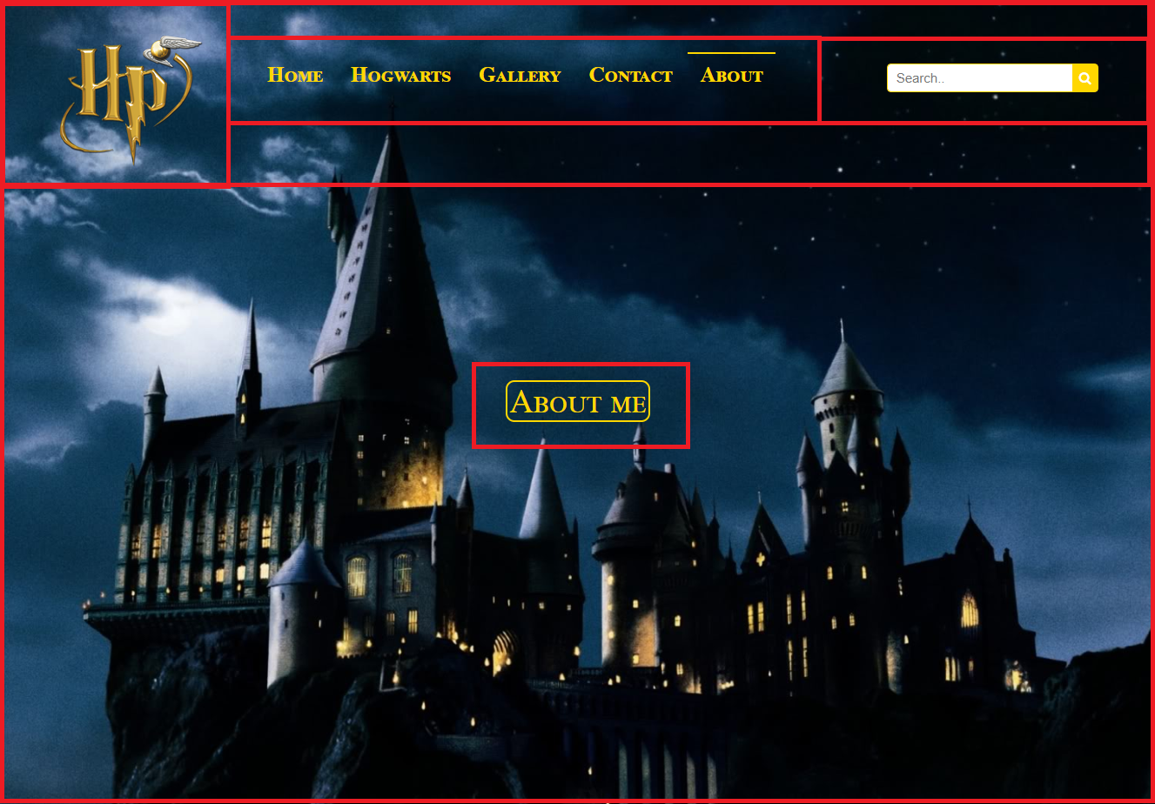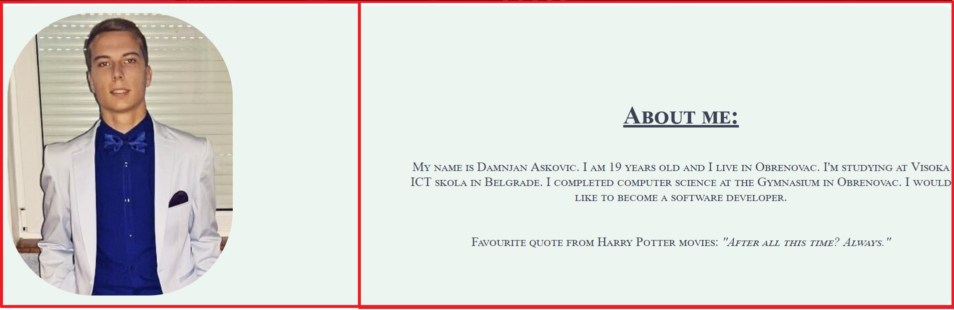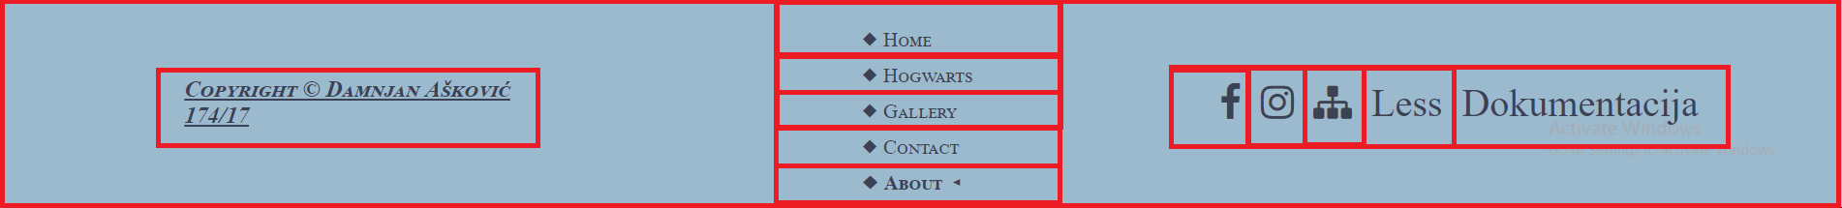

<!DOCTYPE html>

<html>

<head>

<title>Pottermania</title>

<meta charset="UTF-8"/>

<meta name="author" content="Askovic Damnjan 174.17"/>

<meta name="keywords" content="Harry Potter, Hogwarts, Magic"/>

<meta name="language" content="English"/>

<meta name="viewport" content="width=device-width, initial-scale=1.0">

<link rel="stylesheet" type="text/css" href="css/about.css">

<link rel="stylesheet" type="text/css" href="css/main.css" />

<link rel="icon" href="images/favicon.ico">

<link rel="stylesheet" href="https://cdnjs.cloudflare.com/ajax/libs/font-awesome/4.7.0/css/font-awesome.min.css">

<link href="http://www.fontsaddict.com/font/harry-potter.html" rel="stylesheet">

</head>

<body>

<div id="omot">

<header>

<div id="pozadina">

<div id="glavni">

<div id="logo">

<a href="index.html"><img src="images/logo.png" alt="Logo"></a>

</div>

<div id="meni" class="topnav">

<ul>

<li><a href="index.html">Home</a></li>

<li class="flexmeni"><a href="index.html">Home</a></li>

<li><a href="hogwarts.html">Hogwarts</a></li>

<li><a href="gallery.html">Gallery</a></li>

<li><a href="contact.html">Contact</a></li>

<li class="aktivanLink"><a href="about.html">About</a></li>

<li><a href="javascript:void(0);" class="icon" onclick="myFunction()">

<span class="fa fa-bars"></span>

</a>

</li>

</ul>

</div>

<div id="pretraga">

<form action="#" method="GET">

<input type="text" name="tbPretraga" id="tbPretraga" placeholder="Search.." />

<button type="submit" id="tbDugme"> <i class="fa fa-search"></i> </button>

</form>

</div>

<div class="cleaner"></div>

<div id="prebaci">

<a href="#author" id="dugmes">About me</a>

</div>

</div>

</div>

</header>

<main>

<div id="author">

<div id="levo">

<img src="images/autor.jpg" id="ja" alt="Autor" class="damnjanImg"/>

</div>

<div id="desno">

<h1>About me:</h1>

<p>My name is Damnjan Askovic. I am 19 years old and I live in Obrenovac. I'm studying at Visoka ICT skola in Belgrade. I completed computer science at the Gymnasium in Obrenovac. I would like to become a software developer.</p>

<p>Favourite quote from Harry Potter movies: <i>"After all this time? Always."</i></p>

</div>

<div class="cleaner"></div>

</div>

</main>

<footer>

<div id="autor">

<h3 id="naslovFuter"><a href="about.html">Copyright &copy Damnjan Ašković 174/17</a></h3>

</div>

<div id="meniFuter">

<ul>

<li><a href="index.html">&#x25C6 Home</a></li>

<li><a href="hogwarts.html">&#x25C6 Hogwarts</a></li>

<li><a href="gallery.html">&#x25C6 Gallery</a></li>

<li><a href="contact.html">&#x25C6 Contact</a></li>

<li class="aktivanLink"><a href="about.html">&#x25C6 About &#x25C2</a></li>

</ul>

</div>

<div id="social">

<ul>

<li><a href="https://www.facebook.com/harrypottermovie/" target="_blank"> <i class="fa fa-facebook"></i></a></li>

<li><a href="https://www.instagram.com/harrypotterfilm/" target="_blank"> <i class="fa fa-instagram"></i></a></li>

<li><a href="sitemap.xml" target="_blank"> <i class="fa fa-sitemap"></i></a></li>

<li><a href="less.txt" target="_blank">Less</a></li>

<li><a href="dokumentacija.docx" target="_blank">Dokumentacija</i></a></li>

</ul>

</div>

</footer>

</div>

1.4. Korišćeni CSS

Svi CSS fajlovi su moji, tj. sam sam ih napisao.

# 2. Organizacija

2.1 Organizacija sajta

ABOUT

GALLERY

CONTACT

HOGWARTS

INDEX

2.2. Mapa sajta

<urlset xmlns="http://www.sitemaps.org/schemas/sitemap/0.9">

<url>

<loc>https://haripoter.000webhostapp.com/index.html</loc>

<lastmod>2018-08-07</lastmod>

<changefreq>daily</changefreq>

<priority>1</priority>

</url>

<url>

<loc>https://haripoter.000webhostapp.com/hogwarts.html</loc>

<lastmod>2018-08-07</lastmod>

<changefreq>daily</changefreq>

<priority>0.8</priority>

</url>

<url>

<loc>https://haripoter.000webhostapp.com/gallery.html</loc>

<lastmod>2018-08-07</lastmod>

<changefreq>daily</changefreq>

<priority>0.8</priority>

</url>

<url>

<loc>https://haripoter.000webhostapp.com/contact.html</loc>

<lastmod>2018-08-07</lastmod>

<changefreq>daily</changefreq>

<priority>0.6</priority>

</url>

<url>

<loc>https://haripoter.000webhostapp.com/about.html</loc>

<lastmod>2018-08-07</lastmod>

<changefreq>daily</changefreq>

<priority>0.5</priority>

</url>

</urlset>

2.3. Stranice

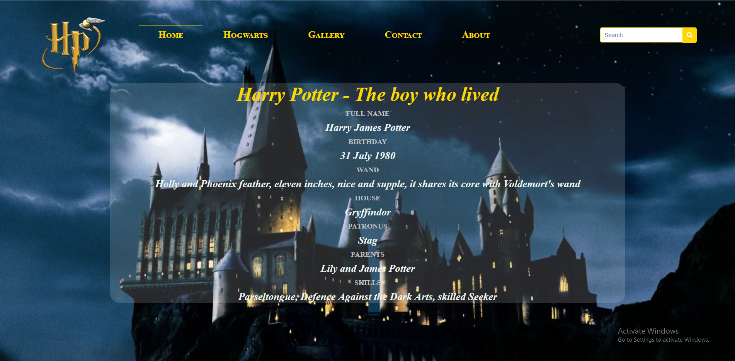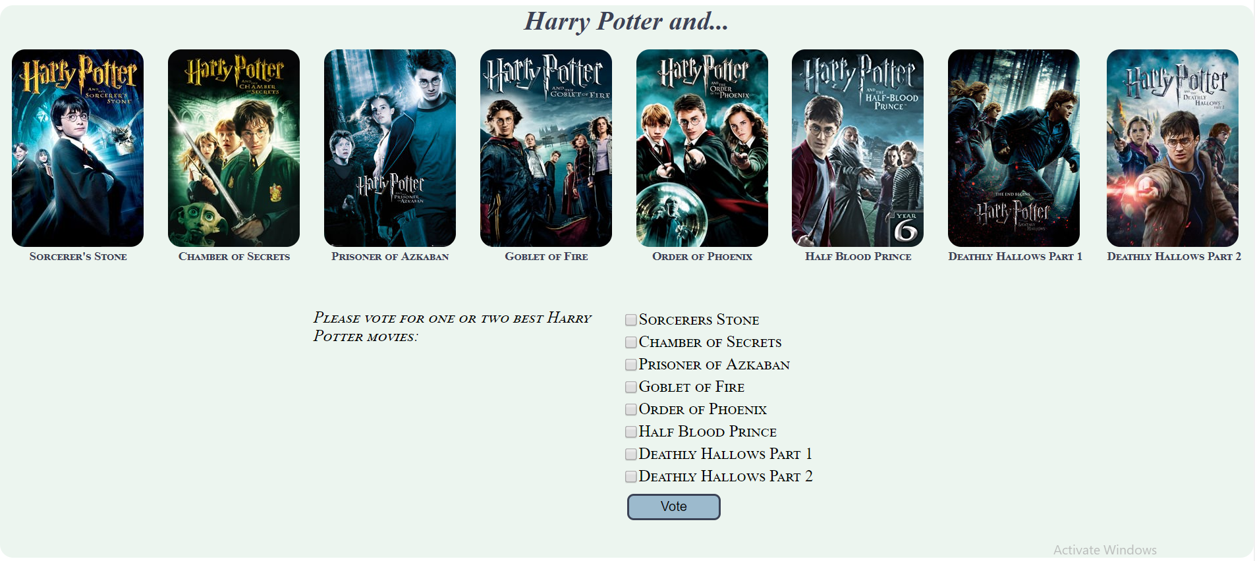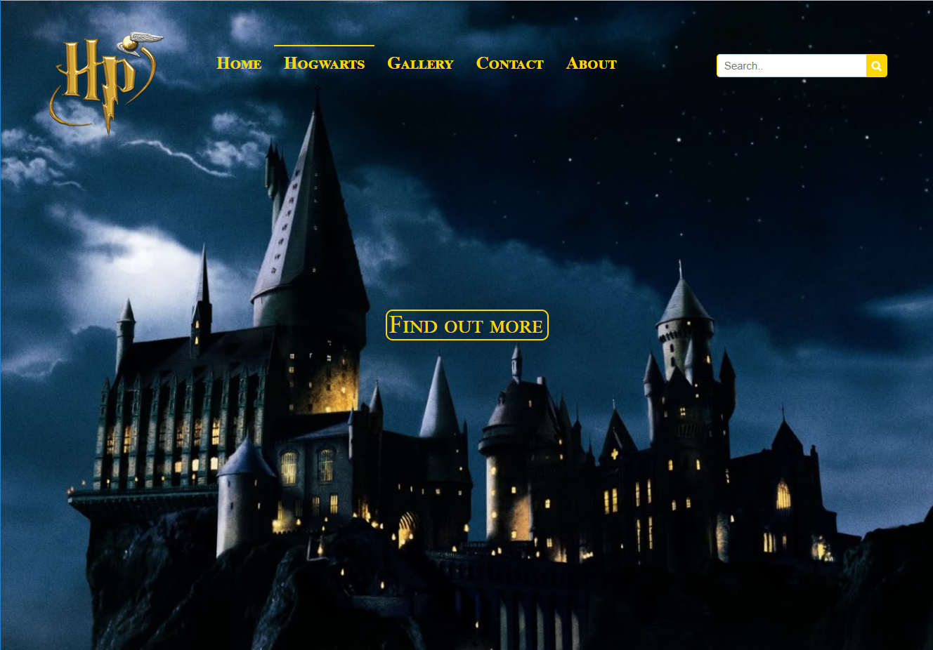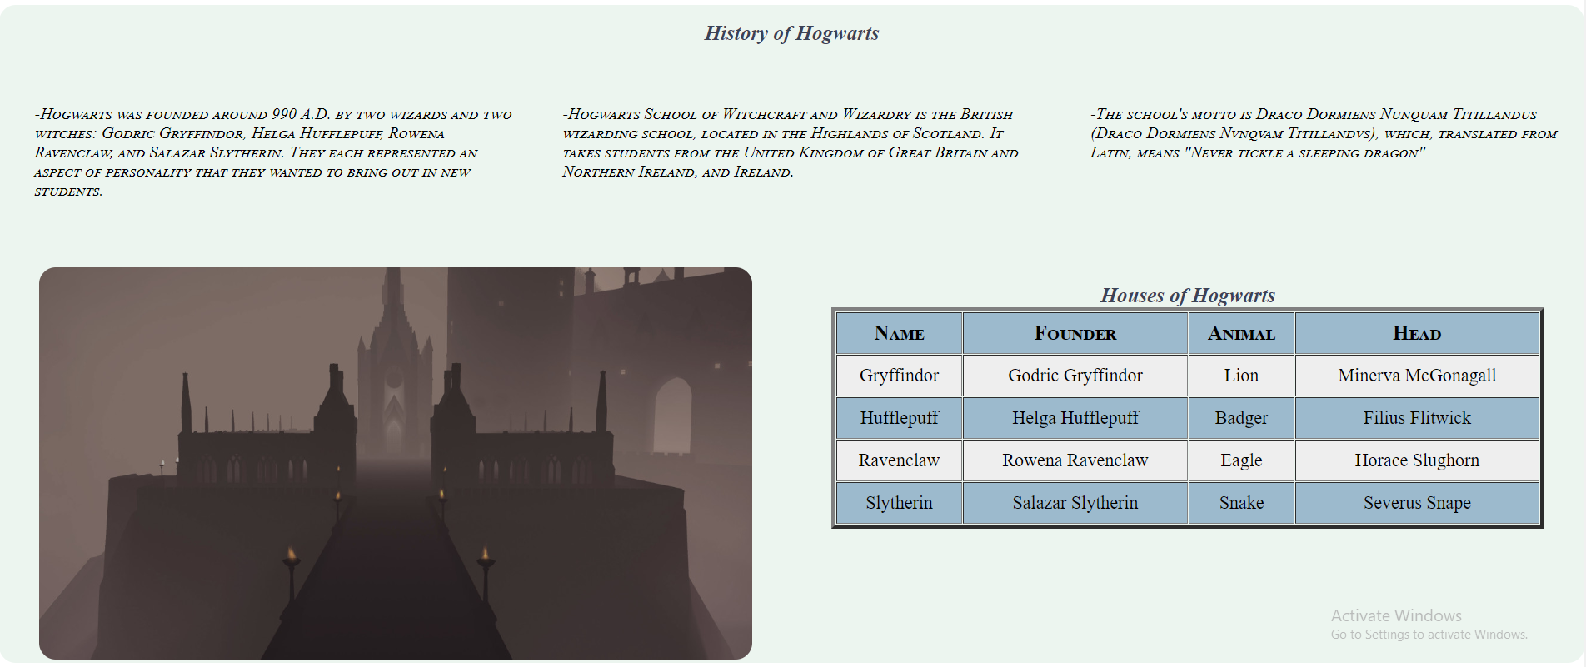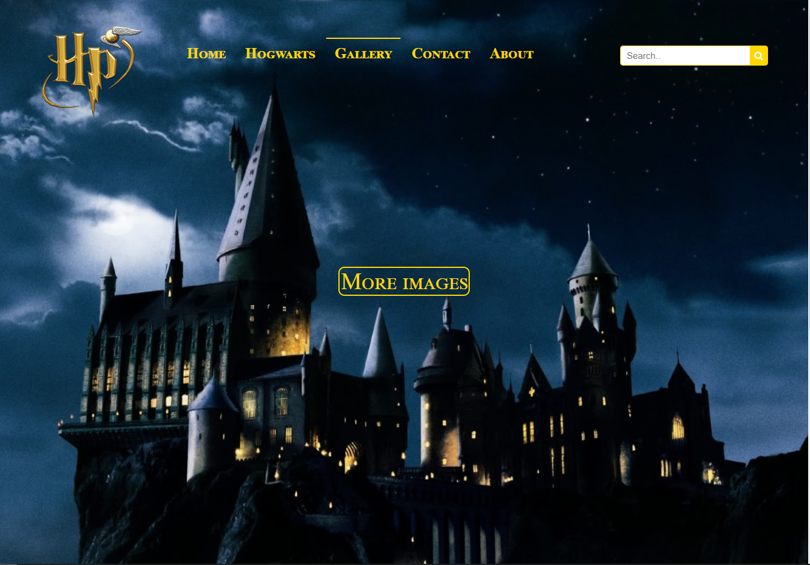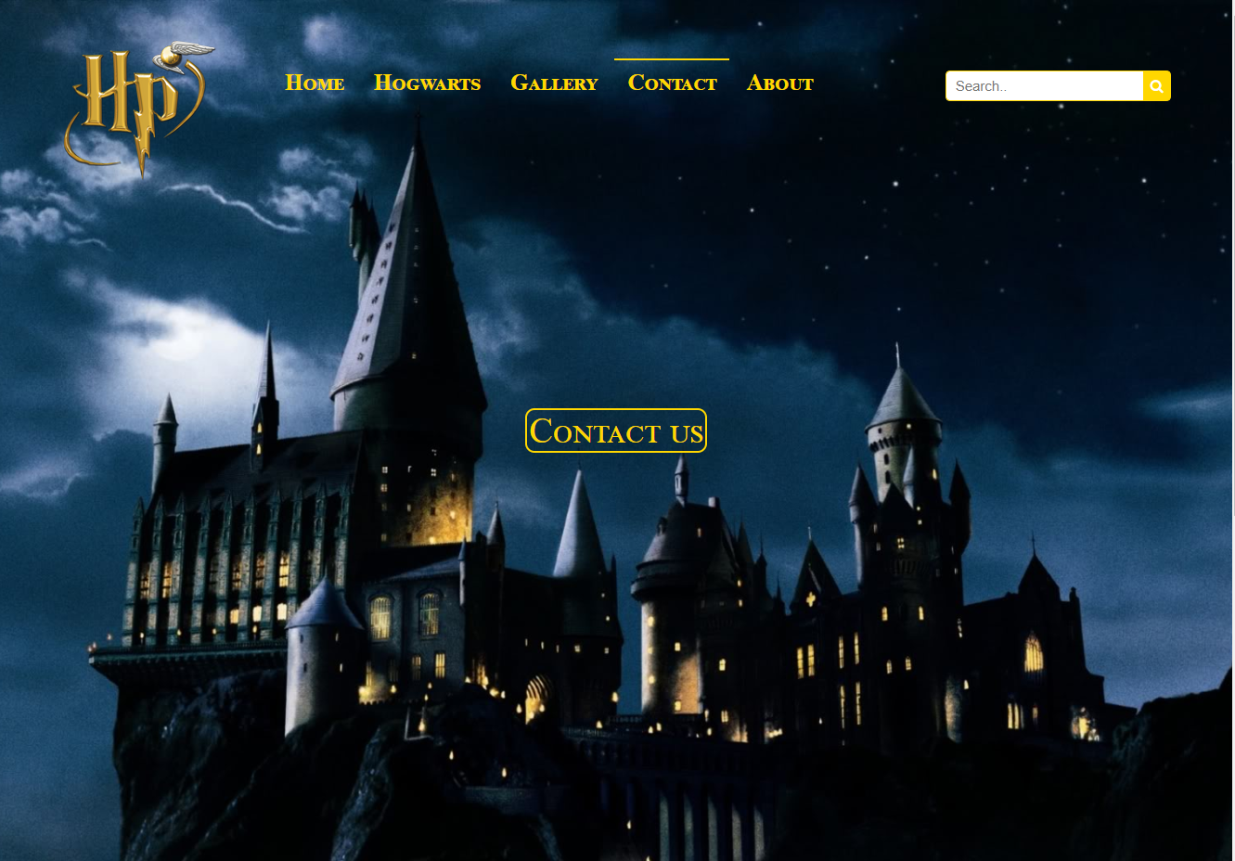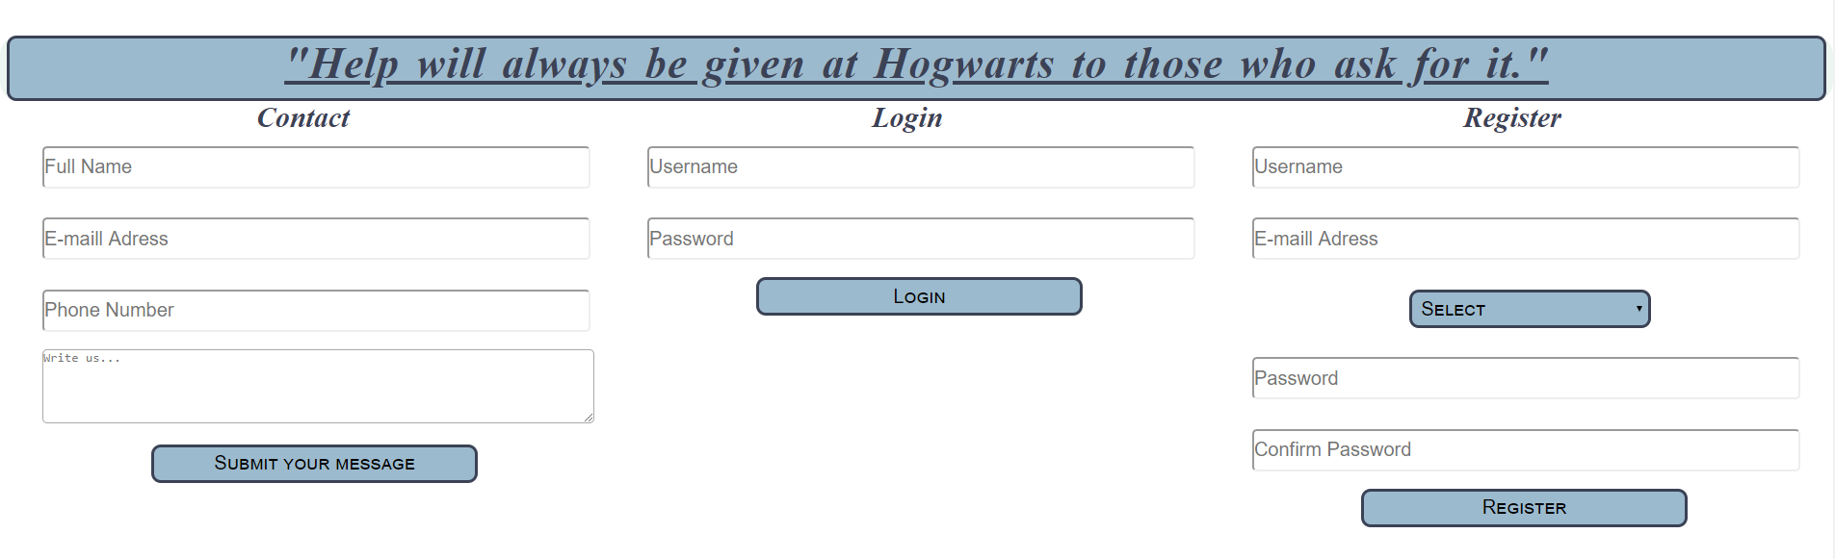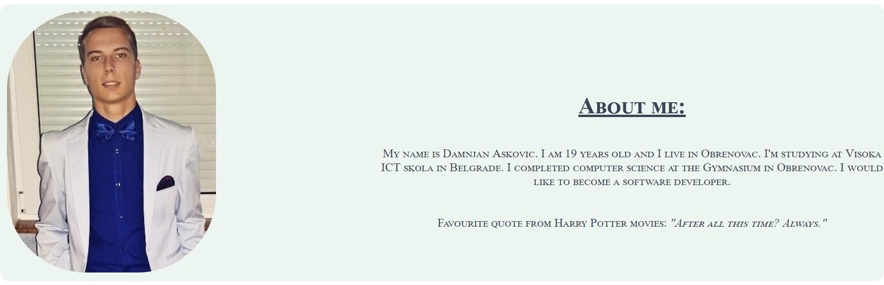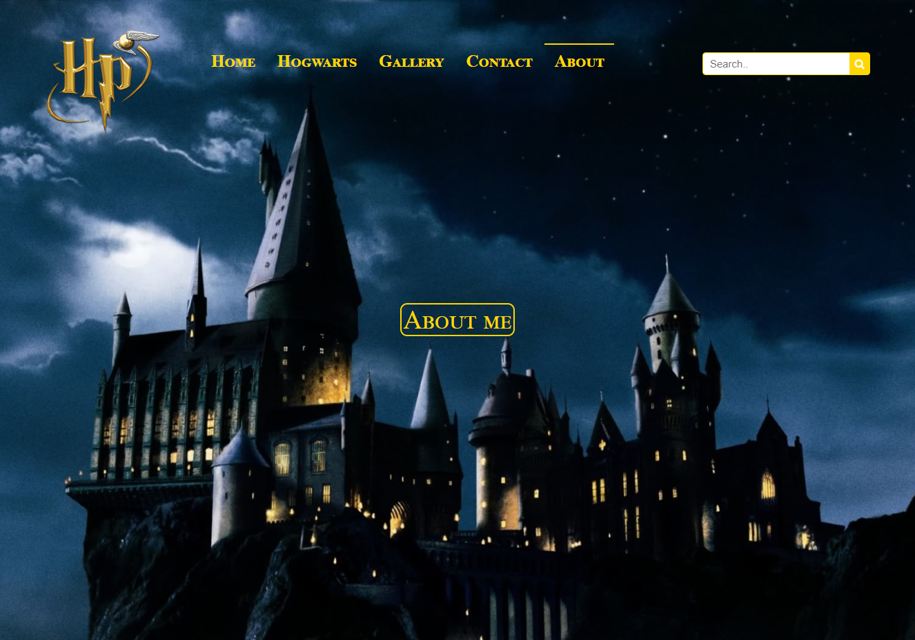

Sav kod sa stranica je moj. Svaka stranica je podeljena u 3 dela, header main I footer.

Na index stranici se nalaze opšte informacije o Hari Poteru koje su smestene u div sa id “more”. Dinamički je napisana čekboks lista za glasanje I napisana funkcija za glasanje koja korisniku prikazuje poruku u zavisnosti od tačnosti čekiranja.

Na stranici hogwarts.html se nalazi dugme koje nakon klika spušta stranu na odredjeni section sa id. Na toj stranici je uradjena zebra na tabeli.

Na stranici gallery.html se takodje nalazi dugme za spuštanje stranice. Pomoću felxslider-a je napravljena galerija.

Na stranici contact.html se nalazi dugme koje nakon klika spušta stranu na odredjeni section. Klikom na dugmad za proveravanje formi dolazi do validacije unetih vrednosti. u Zavisnosti od toga da li su u formu uneti ispravni podaci, u neuredjenoj listi ispod dugmadi će se ispisati vrednosti podataka. U suprotnom ukoliko ima grešaka takodje će se ispisati u neuredjenoj listi.

Na stranici about.html se nalazi dugme koje nakon klika spušta stranu na main, I nakon 3 sekunde pomoću funkcije FadeIn(), slika se pojavljuje.

**3. Kodovi**

Kod za stranicu index.html:

<script src="https://ajax.googleapis.com/ajax/libs/jquery/1.11.2/jquery.min.js"></script>

<script>

function myFunction() {

var x = document.getElementById("meni");

if (x.className === "topnav") {

x.className += " responsive";

} else {

x.className = "topnav";

}

}

function loadMoivesChb(){

var movies = ["Sorcerers Stone", "Chamber of Secrets", "Prisoner of Azkaban", "Goblet of Fire", "Order of Phoenix", "Half Blood Prince", "Deathly Hallows Part 1", "Deathly Hallows Part 2"];

var movieList = "<ul>"

for( var i=0; i < movies.length; i++) {

movieList += "<li><input type='checkbox' value='" + movies[i] + "' name='chbxVote'>" + movies[i] + "<br></li>"

}

movieList += "</ul>"

document.getElementById("moviesList").innerHTML = movieList;

}

function proveraGlasanja() {

var glasovi = document.getElementsByName("chbxVote");

var izabrano = "";

var vote = 0;

for(var i=0; i < glasovi.length ; i++){

if(glasovi[i].checked) {

vote++;

izabrano += "<i><p>Your choice "+ vote + ": " + glasovi[i].value + "</p></i>";

}

}

if(vote > 2) {

izabrano = "<p><b>You chose more than you can.</b></p>"

} else if(vote == 0){

izabrano = "<p><b>Choose two movies.</b></p>"

} else {

$("#btnVote").hide();

}

document.getElementById("vote").innerHTML = izabrano;

}

window.onload = function() {

loadMoivesChb();

document.getElementById("btnVote").addEventListener("click",proveraGlasanja);

}

</script>

Kod za stranicu hogwarts.html:

<script src="https://ajax.googleapis.com/ajax/libs/jquery/1.11.2/jquery.min.js"></script>

<script>

function myFunction() {

var x = document.getElementById("meni");

if (x.className === "topnav") {

x.className += " responsive";

} else {

x.className = "topnav";

}

}

$(document).ready(function() {

$('table tbody tr:even').css('background-color','#9CBACD')

$('table tbody tr:odd').css('background-color','#eee')

});

</script>

Kod za stranicu gallery.html

<script src="https://ajax.googleapis.com/ajax/libs/jquery/1.11.2/jquery.min.js"></script>

<script src="plugin/FlexSlider/jquery.flexslider-min.js"></script>

<script>

function myFunction() {

var x = document.getElementById("meni");

if (x.className === "topnav") {

x.className += " responsive";

} else {

x.className = "topnav";

}

}

$(window).load(function() {

$('.flexslider').flexslider({

animation: "slide"

});

});

</script>

Kod za stranicu contact.html

<script src="https://ajax.googleapis.com/ajax/libs/jquery/1.11.2/jquery.min.js"></script>

<script>

function myFunction() {

var x = document.getElementById("meni");

if (x.className === "topnav") {

x.className += " responsive";

} else {

x.className = "topnav";

}

}

var reEmail = /^\w+([\.-]?\w+)*@\w+([\.-]?\w+)*(\.\w{2,3})+$/;

var reUsername = /^[a-zA-Z0-9]{3,30}$/;

var rePass = /^(?=.*?[0-9])(?=.*?[A-Z])(?=.*?[#?!@$%^&*\-_]).{8,}$/;

function proveraKontakt() {

var nameContact = document.getElementById("fullName");

var phoneContact = document.getElementById("phoneContact");

var textContact = document.getElementById("textContact");

var reName = /^[A-Z][a-z]{1,11}(\s[A-Z][a-z]{1,11})+$/;

var rePhone = /^\(?([0-9]{3})\)?[-. ]?([0-9]{3})[-. ]?([0-9]{4})$/;

var reText = /^[a-zA-Z0-9_ ]{3,}$/;

var nizGreske = [];

var nizOk = ["You have successfully sent a message: "];

if(!reName.test(nameContact.value)) {

nizGreske.push("You didn't enter the Name and Surname correctly!")

} else {

nizOk.push(nameContact.value);

}

if(!reEmail.test(emailContact.value)) {

nizGreske.push("You didn't enter Email correctly!")

} else {

nizOk.push(emailContact.value);

}

if(!rePhone.test(phoneContact.value)) {

nizGreske.push("You didn't enter Phone correctly!")

} else {

nizOk.push(phoneContact.value);

}

if(!reText.test(textContact.value)) {

nizGreske.push("You didn't enter your message correctly! Your message needs to have at least 3 characters!")

} else {

nizOk.push(textContact.value);

}

var lista = "<ul>";

if(nizGreske != 0) {

for(var i=0; i < nizGreske.length; i++) {

lista += "<li style='color:#ff0000'>" + nizGreske[i] + "</li>"

}

} else {

for(var i=0; i < nizOk.length; i++) {

lista += "<li style='color:#48688a'>" + nizOk[i] + "</li>";

$("#contactForm").trigger("reset");

}

}

lista += "</ul>"

$("#validInfo").html(lista);

}

function proveraLogin() {

var username = document.getElementById("usernameLogin");

var password = document.getElementById("passwordLogin");

var nizGreske = [];

var nizOk = [];

if(!reUsername.test(username.value)) {

nizGreske.push("You didn't enter Username correctly!")

} else {

nizOk.push(username.value);

}

if(!rePass.test(password.value)) {

nizGreske.push("You didn't enter Password correctly!")

} else {

nizOk.push(password.value);

}

var lista = "<ul>";

if(nizGreske != 0) {

for(var i=0; i < nizGreske.length; i++) {

lista += "<li style='color:#ff0000'>" + nizGreske[i] + "</li>"

}

} else {

lista = "<li style='color:#48688a'>You have successfully logged in!</li>"

}

lista += "</ul>";

$("#loginForm").trigger("reset");

$("#validLogin").html(lista);

}

function proveraRegister() {

var username = document.getElementById("usernameRegister");

var password = document.getElementById("passwordRegister");

var confPass = document.getElementById("confPasswordRegister");

var email = document.getElementById("emailRegister");

var houseDdl = document.getElementById("ddlHouses");

var selectedHouse = houseDdl.options[houseDdl.selectedIndex].value;

var nizGreske = [];

var nizOk = [];

if(!reUsername.test(username.value)) {

nizGreske.push("You didn't enter Username correctly. Username must be composed of letters or numbers with a length of 3 to 30 characters!")

} else {

nizOk.push("Your username is: " + username.value);

}

if(!reEmail.test(email.value)) {

nizGreske.push("You didn't enter Email correctly!");

} else {

nizOk.push("Your email is: " + email.value);

}

if(selectedHouse == "0") {

nizGreske.push("You didn't choose a house!");

} else {

nizOk.push("You choose the house: " + selectedHouse);

}

if(!rePass.test(password.value)) {

nizGreske.push("You didn't enter Password correctly. Password must have a large letter, a number, a special character and mustn't be shorter than 8 characters!")

password.value = "";

confPass.value = "";

} else if(password.value != confPass.value) {

nizGreske.push("You didn't enter the same password!");

password.value = "";

confPass.value = "";

}

var lista = "<ul>";

if(nizGreske != 0) {

for(var i=0; i < nizGreske.length; i++) {

lista += "<li style='color:#ff0000'>" + nizGreske[i] + "</li>"

}

} else {

for(var i=0; i < nizOk.length; i++) {

lista += "<li style='color:#48688a'>" + nizOk[i] + "</li>"

}

$("#registerForm").trigger("reset");

}

lista += "</ul>"

$("#validReg").html(lista);

}

function loadHouses() {

var houses = ["Gryffindor", "Hufflepuff", "Ravenclaw", "Slytherin"];

var ispis = "<select id='ddlHouses' class='houses-select'>";

ispis += "<option value = 0>Select</option>";

for(var i=0; i < houses.length; i++) {

ispis += "<option value='" + houses[i] + "'>" + houses[i] + "</option>";

}

ispis += "</select></br></br>";

$("#passwordRegister").before(ispis);

}

window.onload = function() {

loadHouses();

document.getElementById("submitContact").addEventListener("click",proveraKontakt);

document.getElementById("btnLogin").addEventListener("click", proveraLogin);

document.getElementById("btnRegister").addEventListener("click", proveraRegister);

}

</script>

Kod za stranicu about.html

<script src="https://ajax.googleapis.com/ajax/libs/jquery/1.11.2/jquery.min.js"></script>

<script>

function myFunction() {

var x = document.getElementById("meni");

if (x.className === "topnav") {

x.className += " responsive";

} else {

x.className = "topnav";

}

}

$("#dugmes").click(function() {

$("#ja").fadeIn(3000).show();

});

</script>